|  |  |  |  |  |
| --- | --- | --- | --- | --- |
|  | | | | |
|  |  |  | |  |
| Course Name: Programming for Data Analytics  **Course Code:** 04638  **Analytics Assignment 1: Exploratory Data Analysis and Reporting**  **Report Title: Data Analytics: A Deep Dive into CO2 Emissions Dataset**  **Group Members:**   * Olatunji Damilare Emmanuel * Innocent Twagirimana * Jules Maurice Mulisa * Abdallah Bitunguranye | | |
|  | |  |

**Abstract**

Understanding CO2 emissions contribution on both a country and continent level is crucial for shaping effective energy policies aimed at mitigating carbon emissions. This study prioritizes tasks such as ranking continents based on their CO2 emissions and identifying the key countries within each continent that significantly contribute to these emissions. To achieve this, the report leverages the comprehensive dataset provided by the United Nations, encompassing data from 1970 to 2020 for 149 countries and their respective CO2 emission contributions. Within the African continent, South Africa stands out as the primary contributor to CO2 emissions, leading the pack. These insights provide a nuanced understanding of the emission dynamics across continents and shed light on the major contributors within Africa.

**Background and Problem Description**

Over the past four decades, the global economy has experienced more than a twofold increase, marking a remarkable achievement [1]. While this growth can be ascribed to diverse factors, the notable surge in industrial output has played a pivotal role on a global scale. This surge has, in turn, closely influenced the levels of CO2 emissions [2] as underlying activities from these factors include burning of oil, coals, petrol and many others [3]. Therefore, the exploration of the intricate relationship between a continent's economic progress and its corresponding carbon dioxide emissions, the identification of top continents significantly contributing to global warming, and the recognition of key contributing countries within these continents have spurred an investigation into the United Nations dataset.

**Methods**

The methodology adopted in utilizing the UN dataset involved a systematic and structured approach. Here are the key steps undertaken:

**Data**

**Selection**

**Data Cleaning and Pre-processing**

**Insight**

**Generation**

**Exploratory Data Analysis (EDA)**

**Results and Discussion**

In this section, we delve into the outcomes of our comprehensive analysis of CO2 emissions dataset. The ensuing discussion will dissect these results, provid, ultimately fostering a deeper comprehension of the complexities surrounding CO2 emissions on both continental and country-specific scales.

**A. Continent-level Contribution:**

**Fig. 1a. Continent-level contribution**

The infographics provide important insights into the environmental impact of carbon dioxide emissions by revealing the differing amounts of emissions across different continents. With more than 102 million metric tons of CO2 emissions, Asia is clearly the continent with the largest emissions [6]. This enormous number illustrates how Asia distinguishes out due to its quick urbanization, industrialization, and population expansion.

**Country-Level Emissions: Africa as a case study**

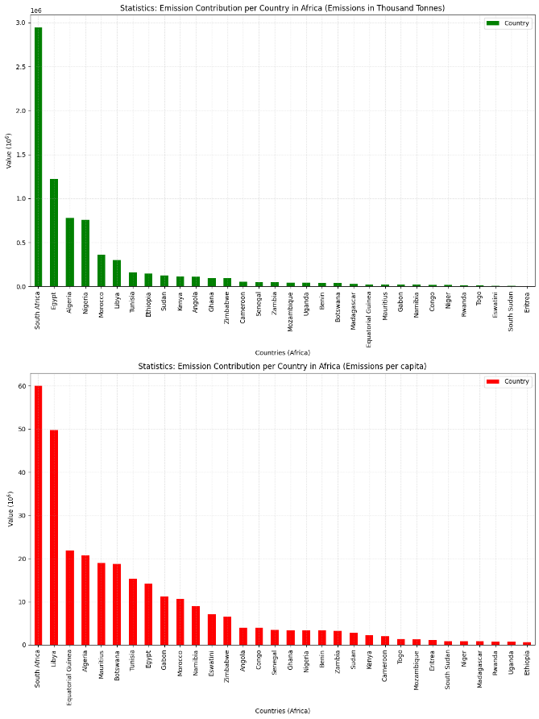

**Fig 1b. Country-Level Emissions: Africa as a case study**

This summary provides an overview of the African countries ranking in terms of CO2 emissions. Leading the list with 2,942,268 metric tons, South Africa demonstrates a substantial contribution to CO2 emissions, reflecting its industrial and economic activities [5]. Following closely, Egypt driven by population density and economic development. This finding highlights the necessity of sustainable development plans that both address environmental issues and promote continental economic expansion.

**Cross-Country Comparison: Average Emission Per Country (1975 to 2020)**

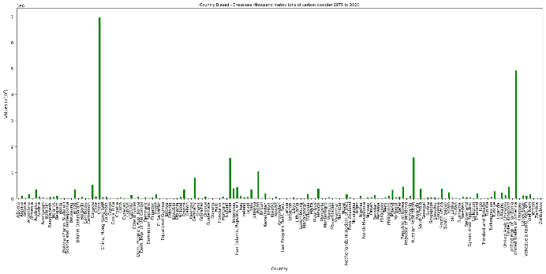Across the seven available continents, China tops the list in terms of CO2 emissions, followed by United State of America.[4] This reality could be attributed to the industrial usefulness of the two countries.

**Total Emissions per Capita (Metric Tons of Carbon dioxide) for each Year:**

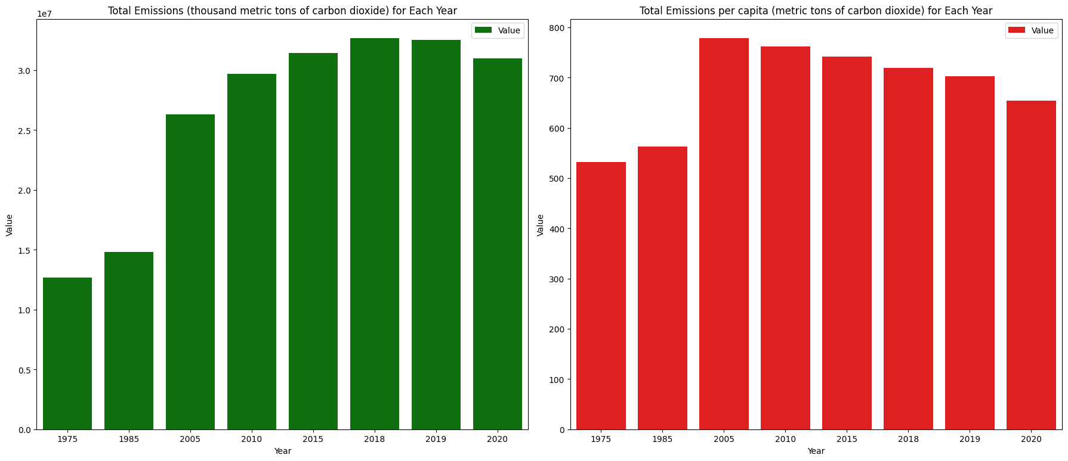

**Fig 2 – CO2 Emissions per Capita (Metric Tons of Carbon dioxide)**

The information above presents the emission per capita (metric tons of carbon dioxide) from 1975 to 2020. The insights derived from Fig. 2 underscore the dynamic nature of individual carbon emissions, reflecting the influence of societal, economic, and global factors. The decreasing trend in recent years suggests a positive shift towards more sustainable practices, with implications for ongoing environmental discussions and policy considerations. It is interesting to note that the substantial drop in emission per capita in 2020 aligns with the global impact of the COVID-19 pandemic. Lockdowns and reduced economic activities contributed to a temporary decline in emissions, highlighting the interconnectedness of environmental factors with global events [7].

**Conclusion**

In summary, the analysis of the UN CO2 data set contributes to a comprehensive understanding of the intricate relationship between socioeconomic factors, geographical regions, and CO2 emissions. These insights are essential for shaping informed policies, fostering sustainable practices, and advancing global efforts to combat climate change.

**References**

[1] P. Knox, J. Agnew, and L. McCarthy, "The Geography of the World Economy," 6th ed. Routledge, 2014. doi: 10.4324/9780203775189.

[2] P. K. Adom, W. Bekoe, F. Amuakwa-Mensah, J. T. Mensah, and E. Botchway, "Carbon dioxide emissions, economic growth, industrial structure, and technical efficiency: Empirical evidence from Ghana, Senegal, and Morocco on the causal dynamics," Energy, vol. 47, no. 1, pp. 314-325, 2012.

[3] University of California Regents, “Burning of Fossil Fuels,” Understanding Global Change, 2022. <https://ugc.berkeley.edu/background-content/burning-of-fossil-fuels/>

[4] “The 5 Countries That Produce the Most Carbon Dioxide (CO2),” Investopedia. <https://www.investopedia.com/articles/investing/092915/5-countries-produce-most-carbon-dioxide-co2.asp#citation-40>

[5] AJLabs, “How much does Africa contribute to global carbon emissions?,” Al Jazeera. https://www.aljazeera.com/news/2023/9/4/how-much-does-africa-contribute-to-global-carbon-emissions#:~:text=Which%20countries%20are%20Africa (accessed Nov. 17, 2023).

[6] “Global energy-related CO2 emissions by region 2022,” Statista. https://statista.com/statistics/205966/world-carbon-dioxide-emissions-by-region/ (accessed Nov. 17, 2023).

[7] C. H. Tan, M. Y. Ong, S. M. Nomanbhay, A. H. Shamsuddin, and P. L. Show, “The Influence of COVID-19 on Global CO2 Emissions and Climate Change: A Perspective from Malaysia,” Sustainability, vol. 13, no. 15, p. 8461, Jul. 2021, doi: 10.3390/su13158461.

‌‌